NCP Class Assignment 2

24/07/2020

CB.EN.U4CSE17348

Q1)

<html>

<head>

<title>Practise Frame</title>

</head>

<frameset rows=",">

<frame src="ADDITIONAL FILES\first.html"/>

<frameset cols=",,\*">

<frame src="ADDITIONAL FILES\two.html"/>

<frame src="ADDITIONAL FILES\three.html"/>

<frame src="ADDITIONAL FILES\four.html"/>

</frameset>

</frameset>

</html>

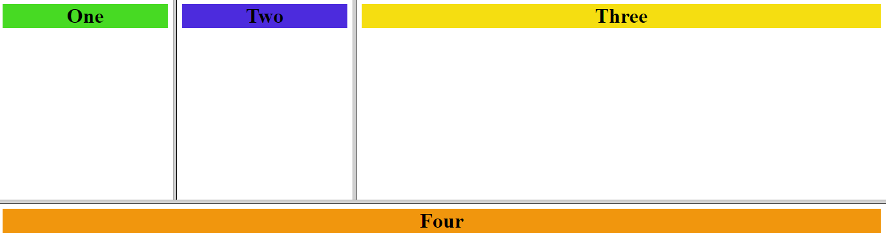

Q2)

<html>

<head>

<title>

Practise form

</title>

</head>

<body>

<form name="PractiseForm" method="post" action="prac1.html">

<fieldset>

<legend>

Personal data

</legend>

<input type="text" >Last Name</input>

<div>

<input type="text" >First Name</input>

<input type="text" >Middle Name</input>

</div>

<input type="text" >Email</input>

<input type="text" >Resume</input>

</fieldset>

<fieldset>

<legend>

Job

</legend>

<div class="row" >

<div class="column">

<p>Position applying for</p>

<select >

<option value="v1" selected="selected">Administration</option>

<option value="v2">Management</option>

<option value="v3">IT</option>

</select>

</div>

<div class="column">

<p>Hourly wages</p>

<input type="text" />

</div>

</div>

<div class="row" >

<div class="column">

<p>Date you can start</p>

<select >

<option value="v1" >June</option>

</select>

<select >

<option value="v2" >15</option>

</select>

<select >

<option value="v3" >2020</option>

</select>

</div>

<div class="column">

<p>Weekly hours<p>

<select >

<option value="v4" >40</option>

</select>

</div>

</div>

</fieldset>

<input type='submit'>

</form>

</body>

</html>

